Phase 3
Privilege Escalation and Persistence

Executive Summary
The Goal of this phase is to identify Privilege escalation vectors and establish persistence trough CRON job on a target VM. Linpeas was used in Enumeration which revealed SUID enabled Nmap Library. This misconfiguration enabled root escalation. A persistence mechanism was then enabled via CRON job to maintain consistent Root access to the Mr. Robot VM.

Tools & Environment
- Kali Linux Environment
- Mr Robot VM
- Metasploit
- Hydra
- Linpeas
- Netdiscover
- Nmap

Methodology
- Reconnaissance
First step is to discover the Mr. Robot VM On the Network. We can do this by switch to Sudo user and using netdiscover command.
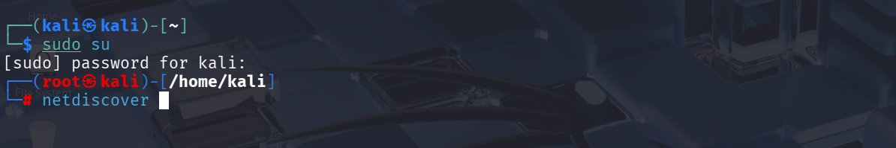

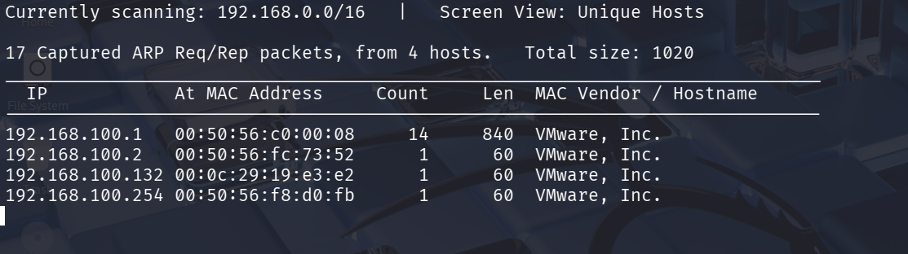
By the Above snapshot/output we can determine the IP address of the Mr. Robot VM = 192.168.100.132

- Nmap Scanning of the Kioptrix
Now we perform Nmap Enumeration/Scan on the Mr Robot VM machine.
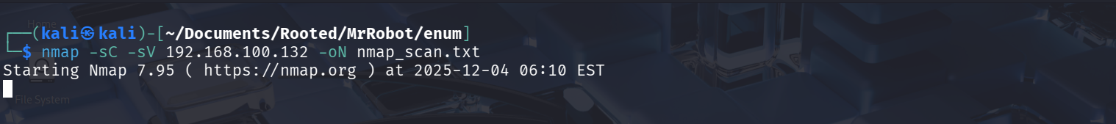
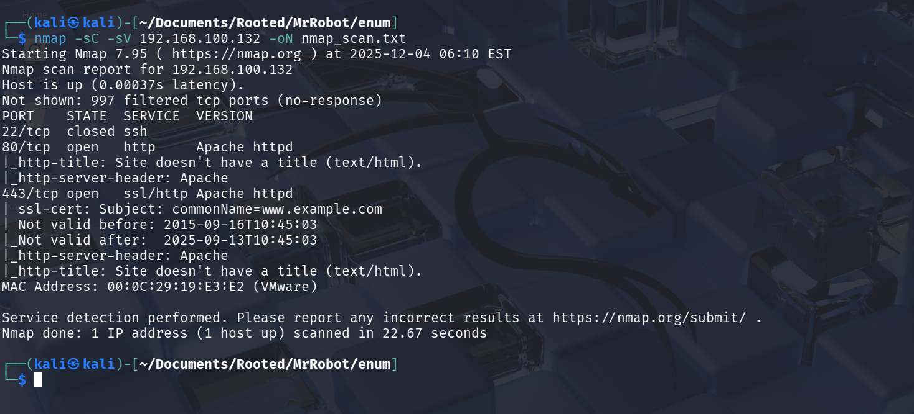
The Scan Resulted in three Open services and the scan output was saved for further processing.

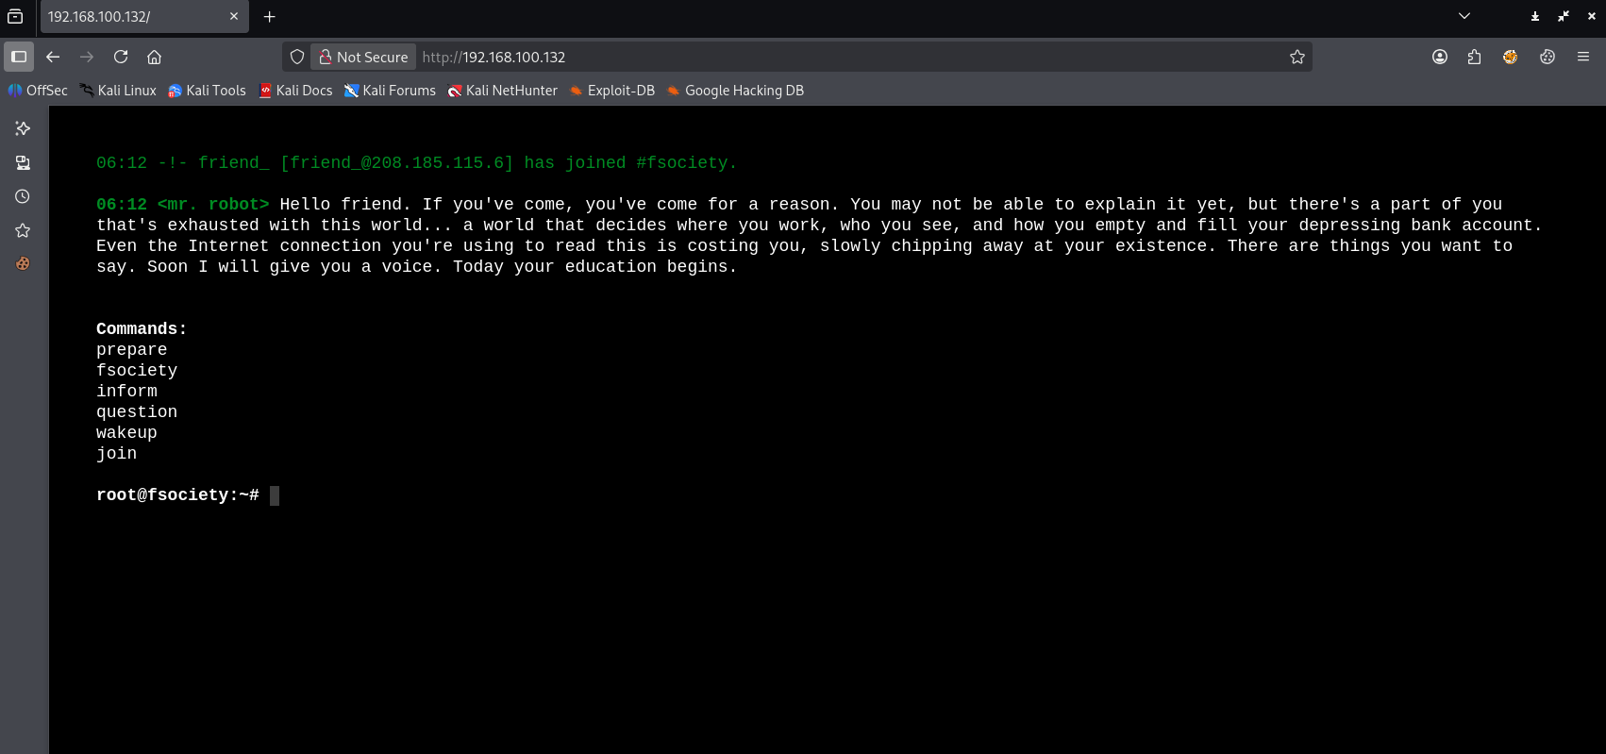
First Look of the website of Mr Robot.

- Subdomain enumeration
We will further enumerate this website using Dirbuster 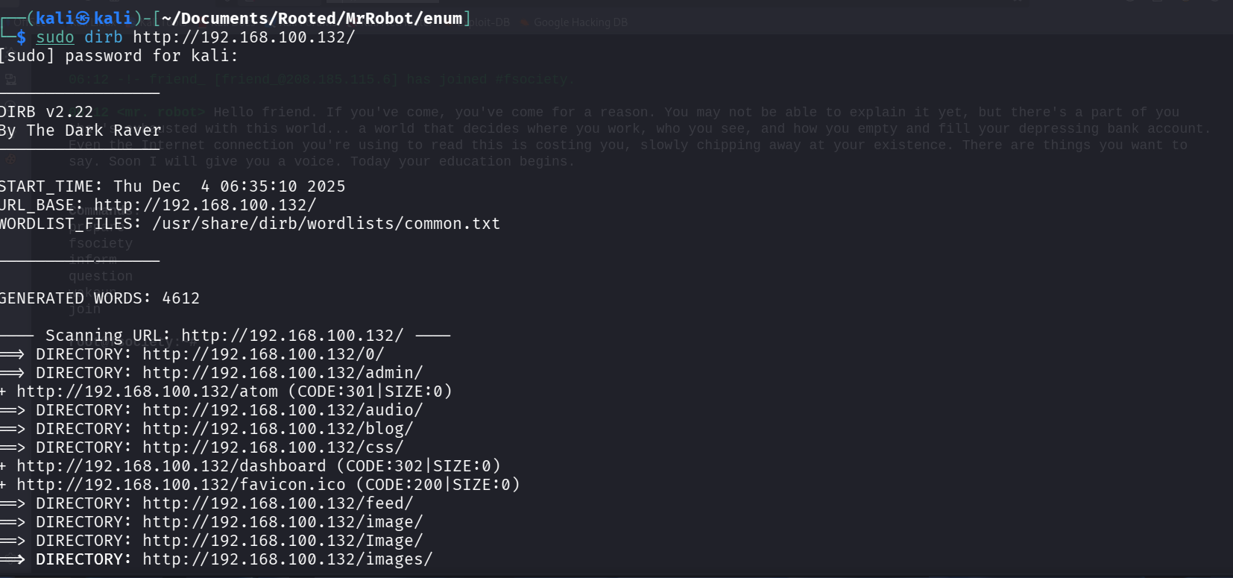
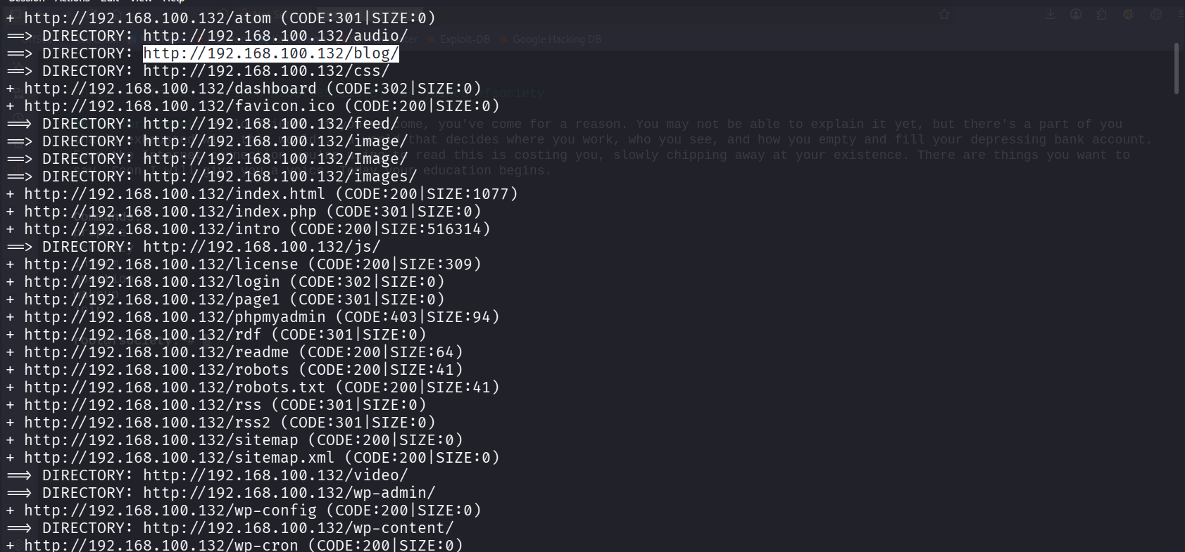
It resulted in several different subdomains. Let’s check robots.txt
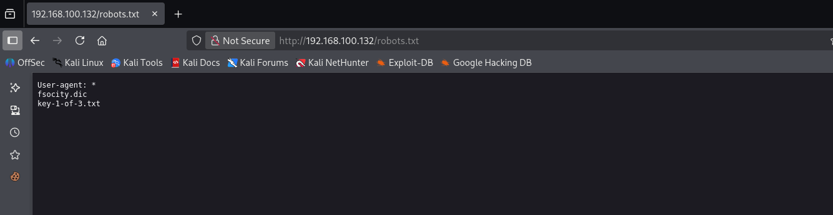
There are two files available in the robots.txt
- Fsociety.dic
- Key-1-of-3.txt
The second file must be one of the flags.
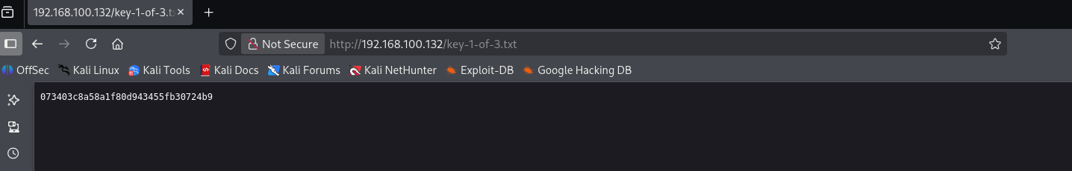
Yes, it’s one of the keys from the task.
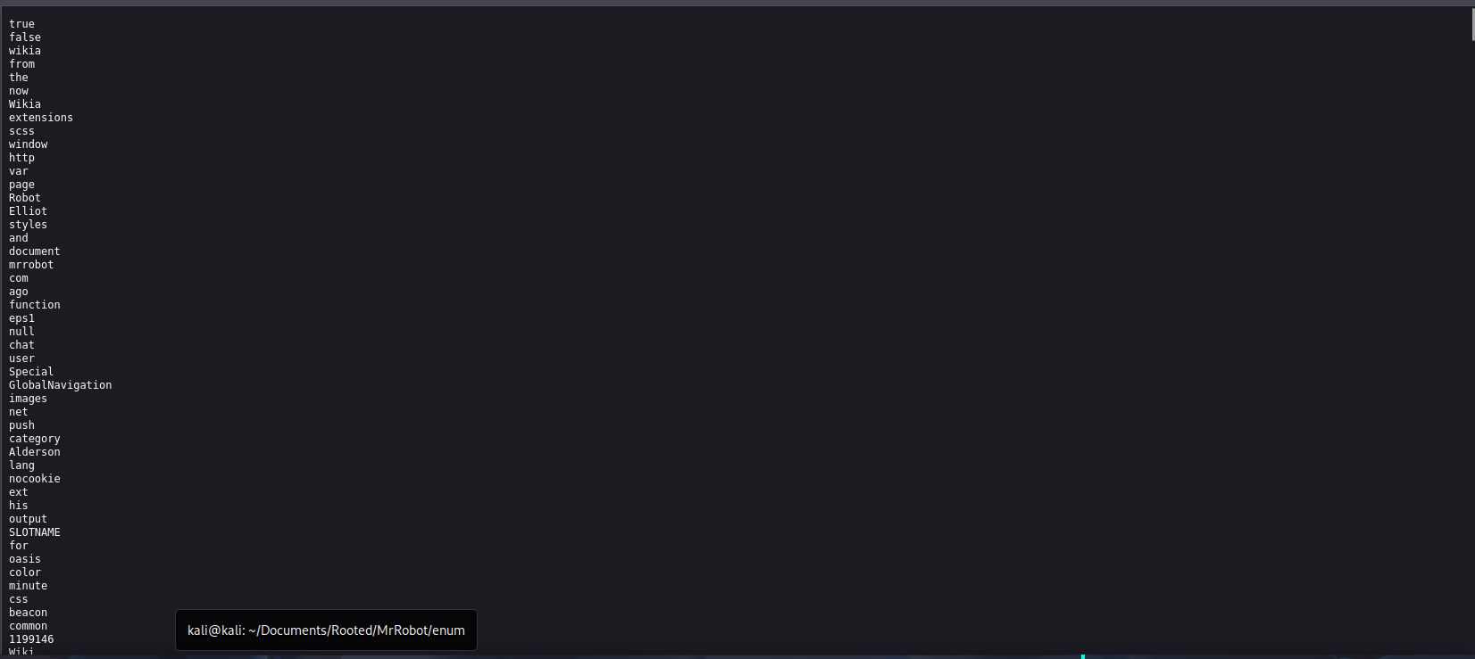
The second file seems to be wordlist of some sort.
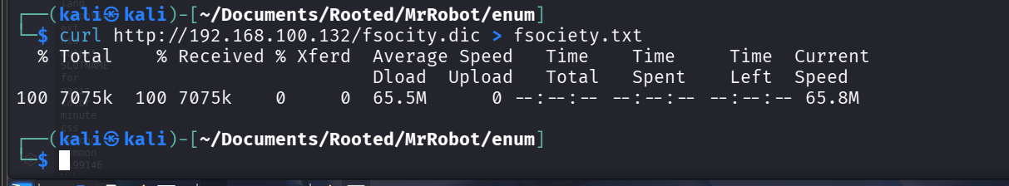
Downloading and keeping it for further testing. From the subdomain enumeration we also found out an admin page.
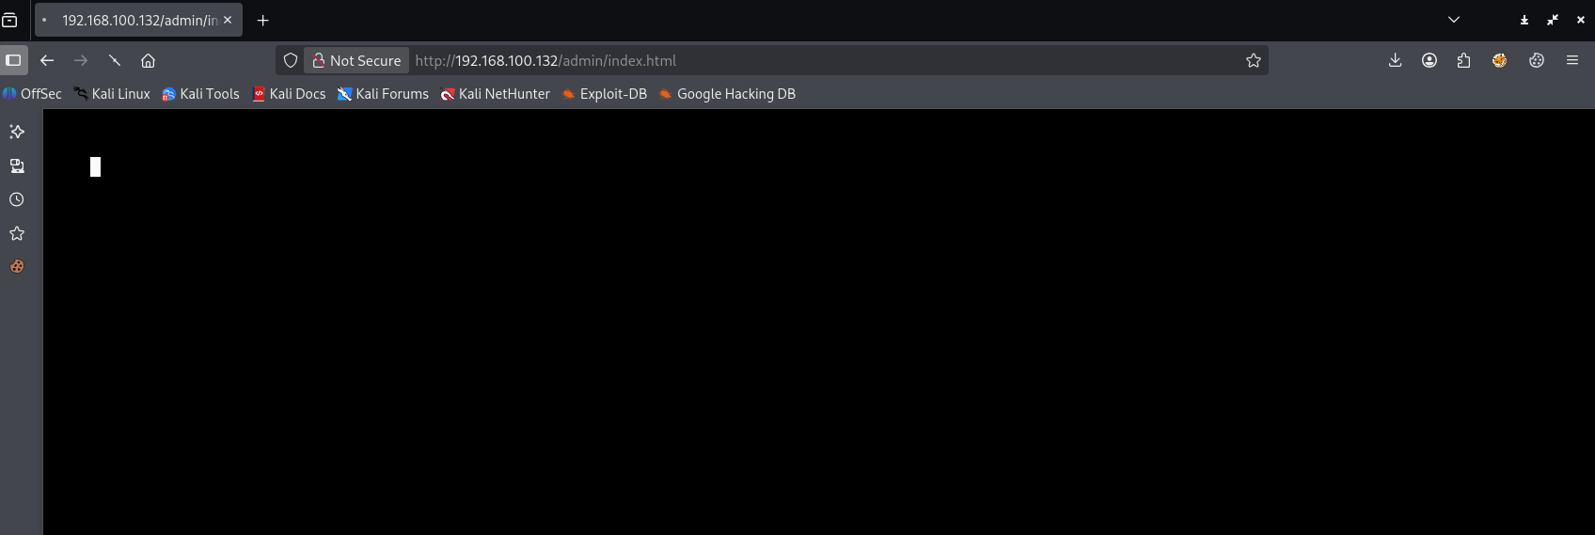
This admin page keeps redirecting. There is also WordPress admin page.
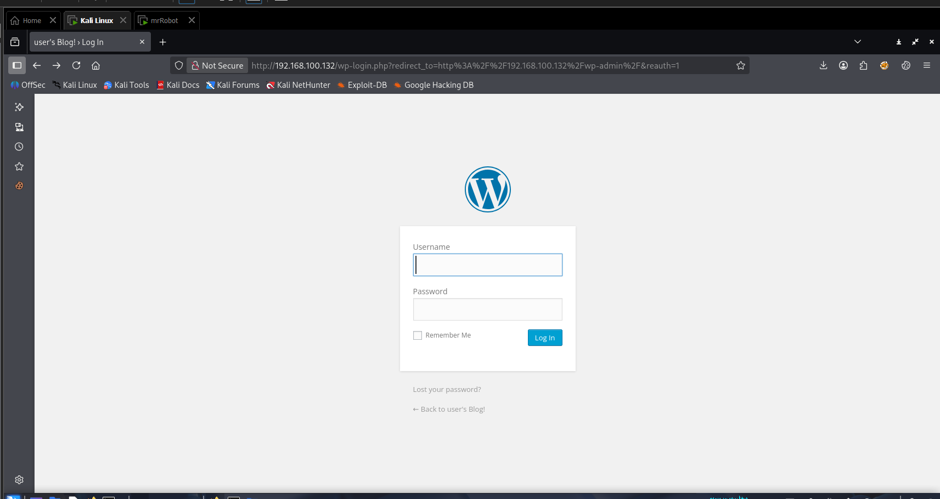

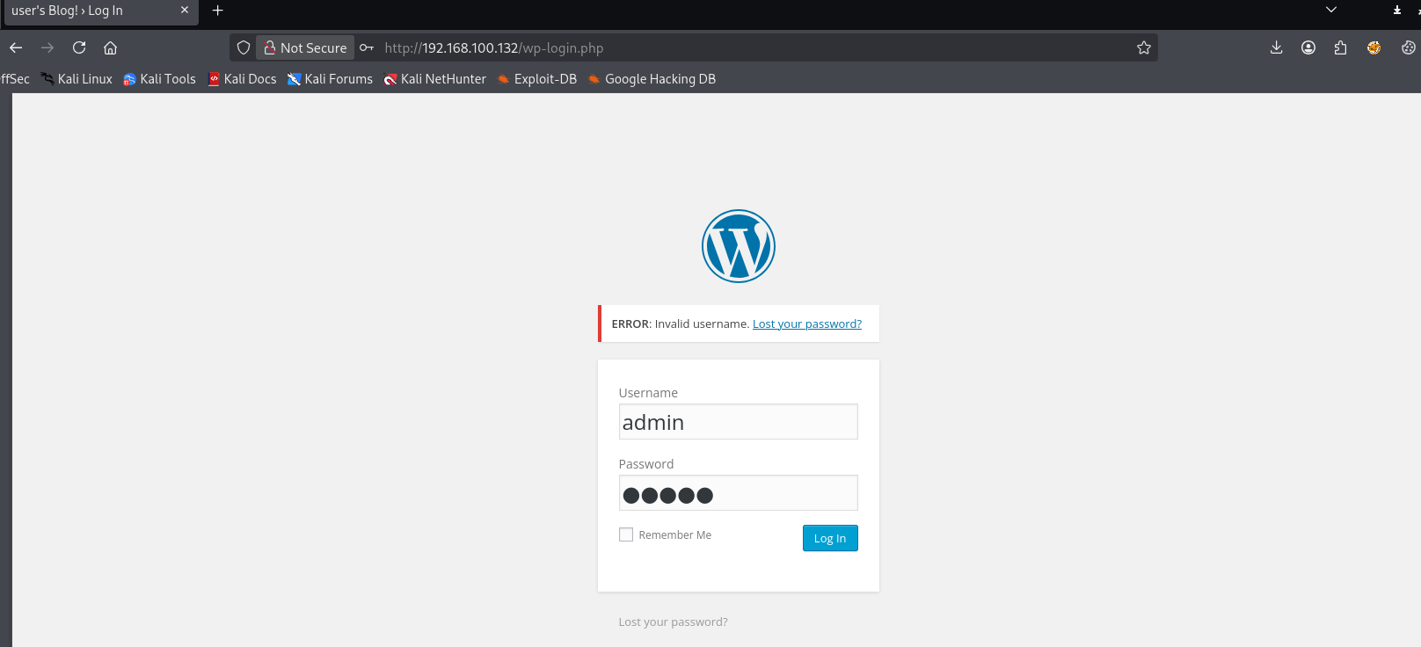
When we enter default credentials the site responds invalid username. By this we can determine that user enumeration might be possible.

- Using Burp suite for User Enumeration
Burp suite Intruder can be used to perform brute force attacks on web applications.
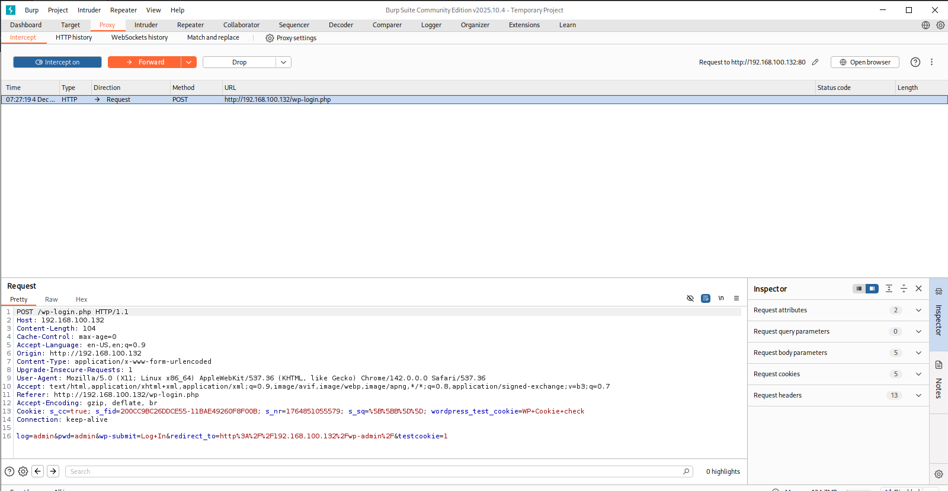
We are going to capture the login request in the burp suite browser and send it to intruder.

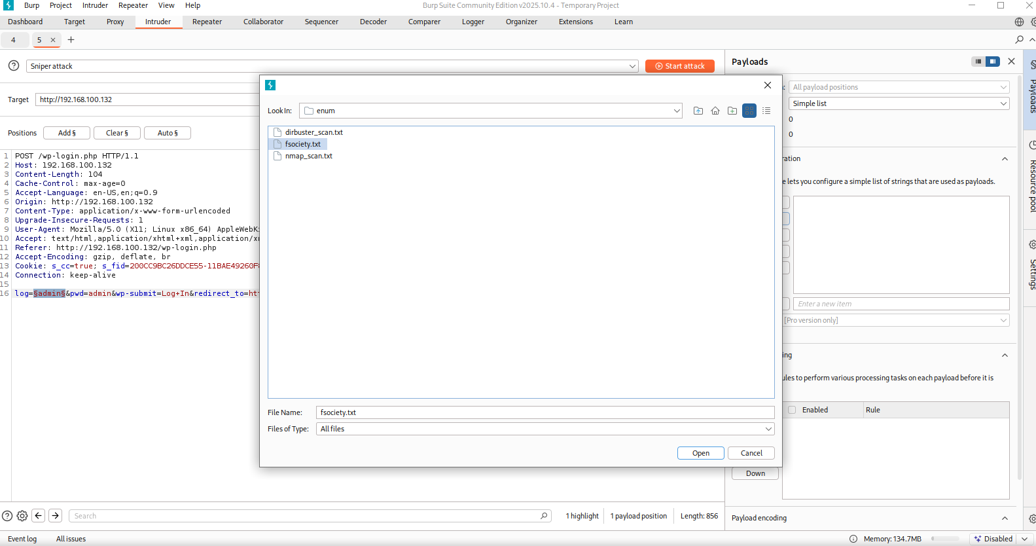
We are configuring to performing user enumeration using the wordlist we got from robots.txt.
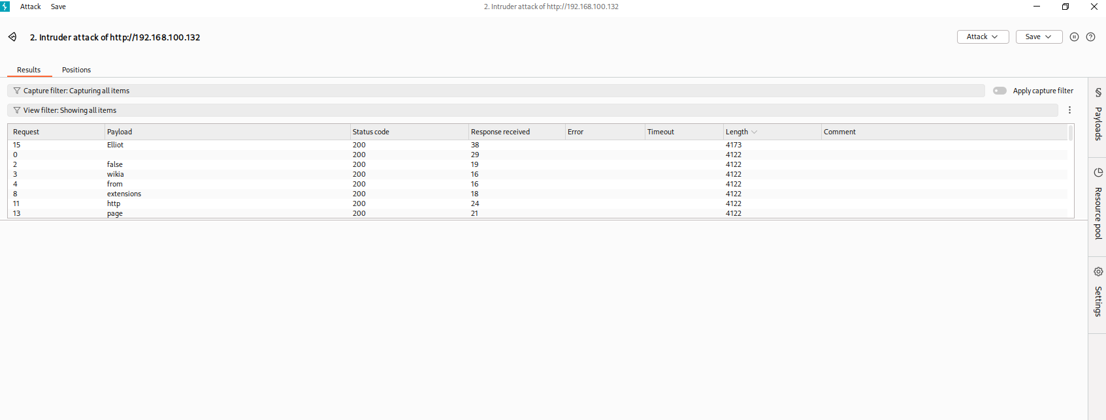
If we filter the response by length, we can find out that one results in different length. We can check that username.
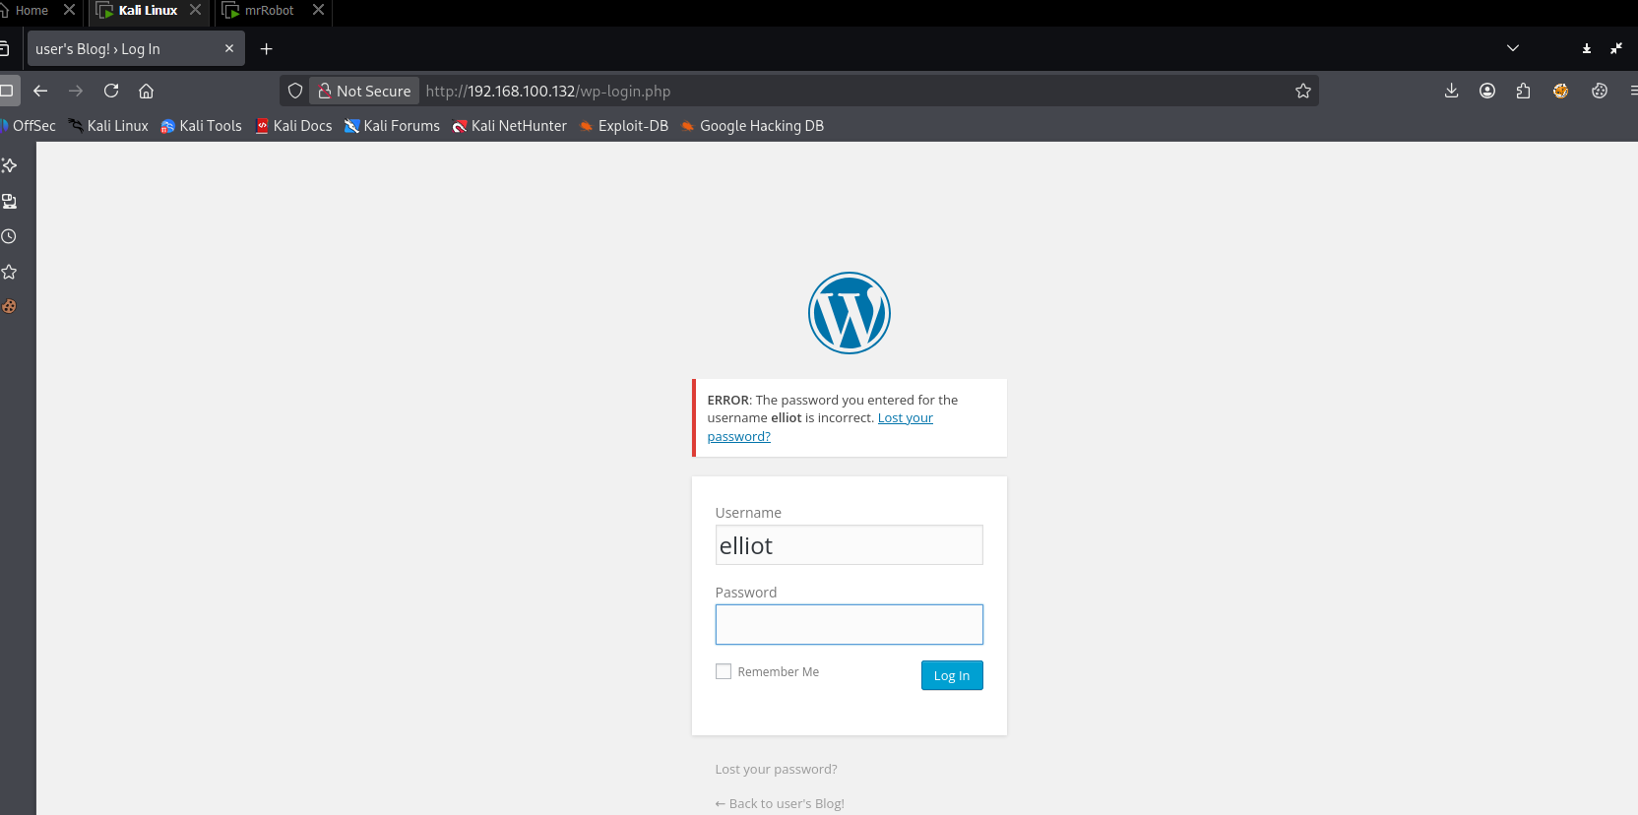

We were able to determine the user Elliot account is present.
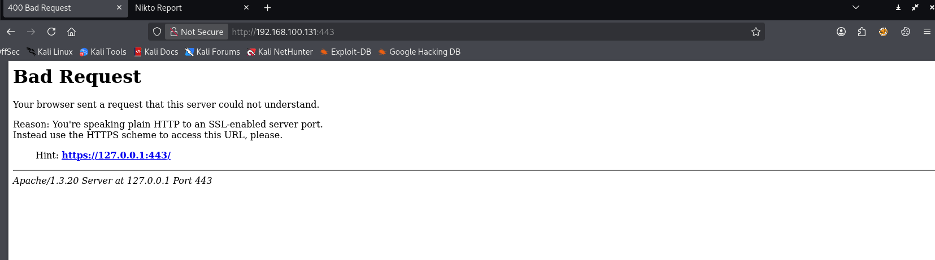

- Performing Dictionary attack using Hydra
Hydra is a tool which helps us to find username and password by automating the dictionary attack. It provides several dictionary attacks on different services. Before Performing the attack, we need to configure the wordlist.
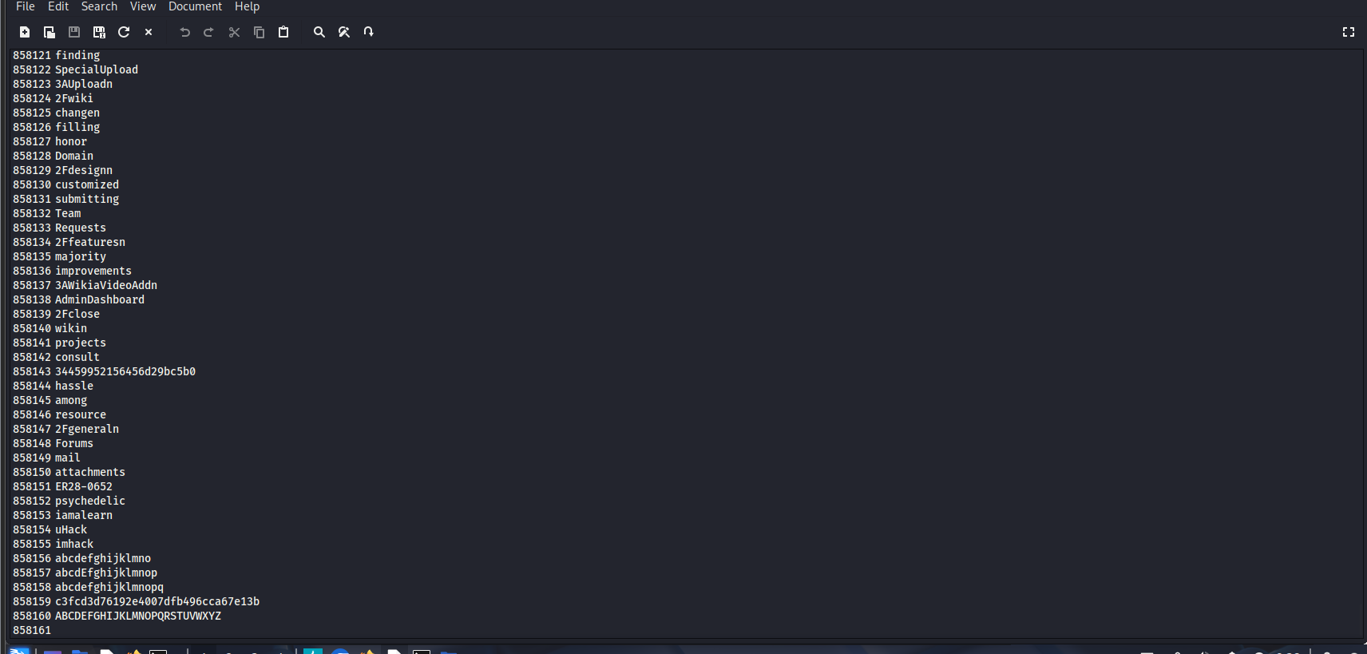
As we can see that this word list is way to big and it takes time to perform the dictionary attack. Let’s shorten this by removing all the duplicates present.
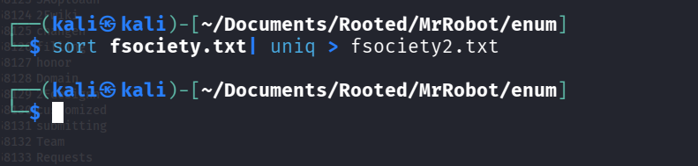

The above commands remove the duplicate words from the wordlist and creates a new wordlist that has no duplicates named fsociety2.txt
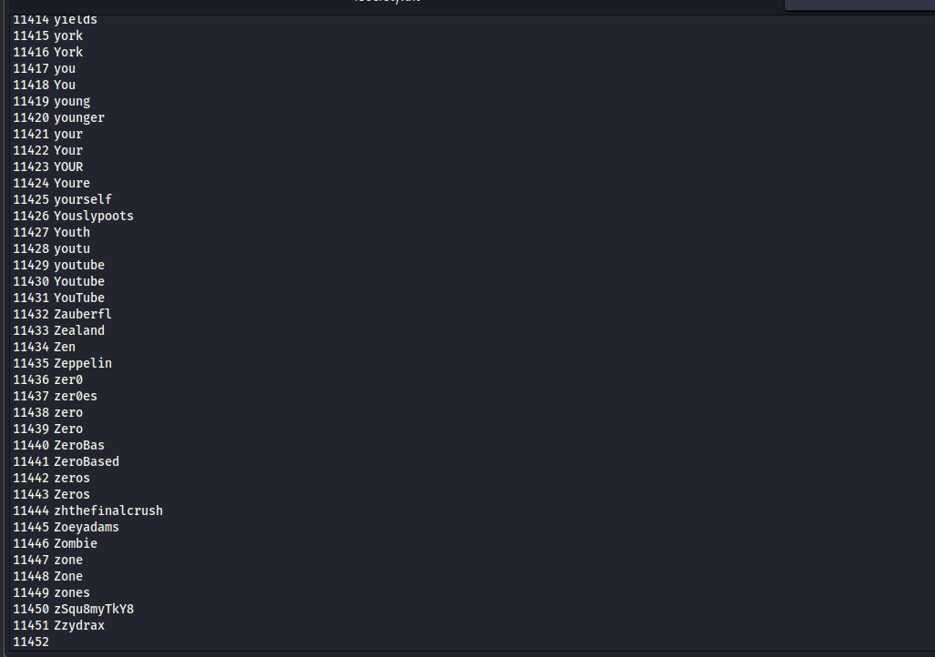
Now the new wordlist is significantly shorter we can perform Dictionary attack significantly faster.
Now we use the above command to perform Dictionary attack on the /wp-login.php page.
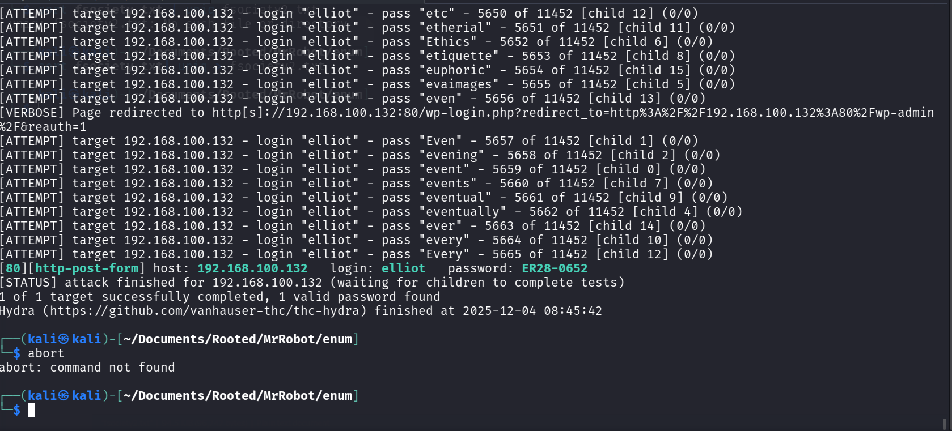
We were able to determine the password for Elliot i.e. ER28-0652
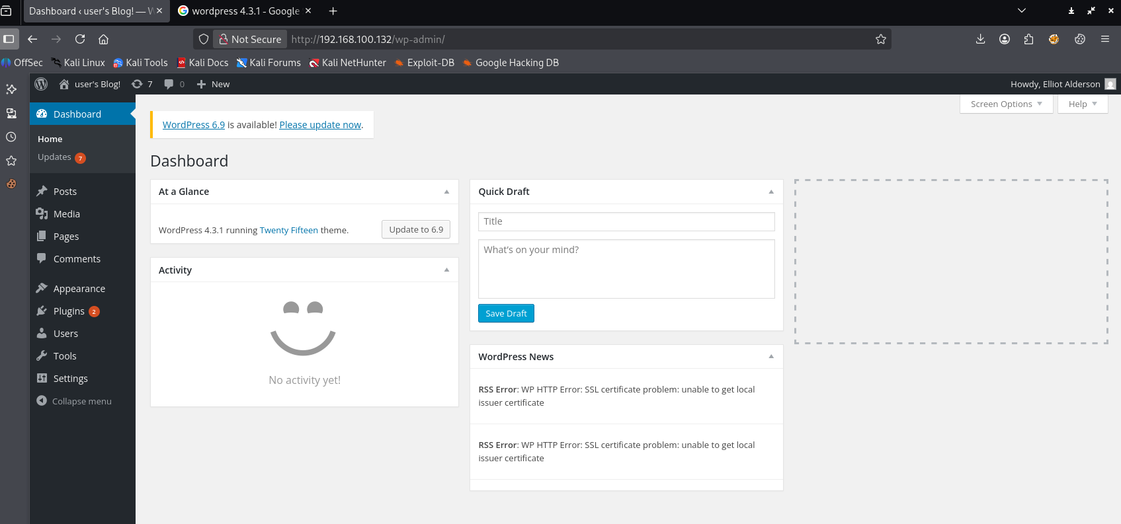
We were successfully able to login in to WordPress login page.

- Creating a Reverse shell using php code
We are going to insert a php reverse shell payload in the 404-template using the WordPress editor tool.

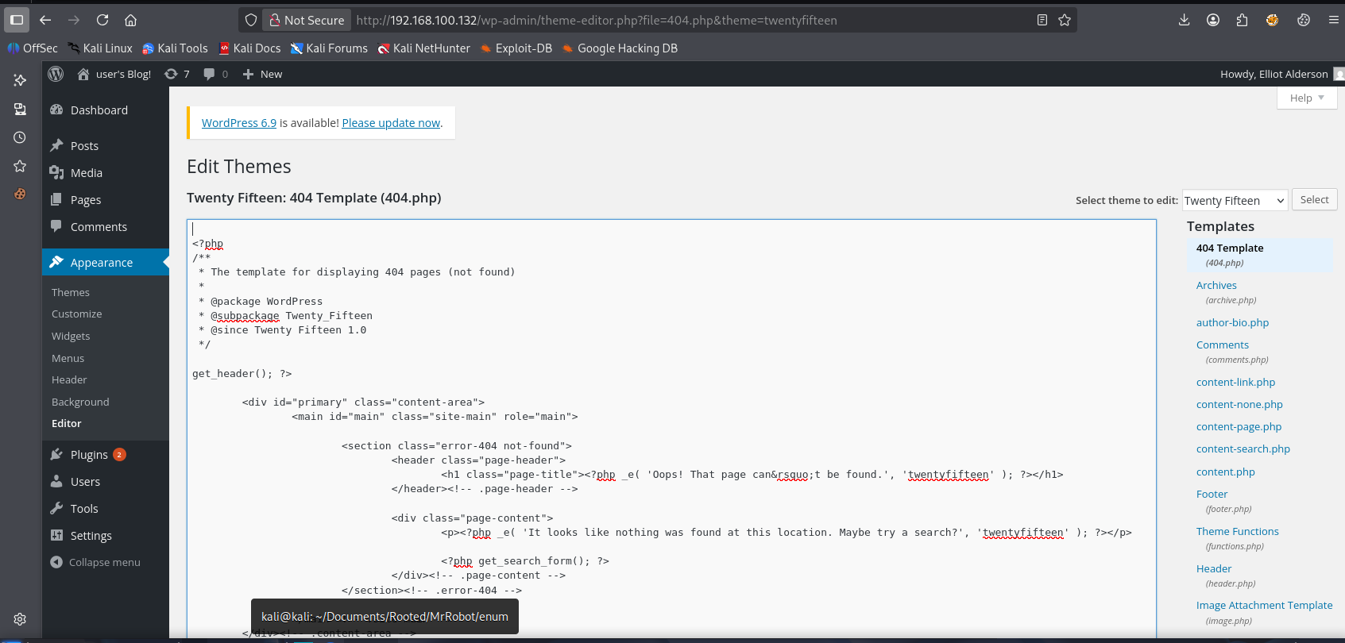
We are going to add the code at the begging of this webpage so it gets executed.
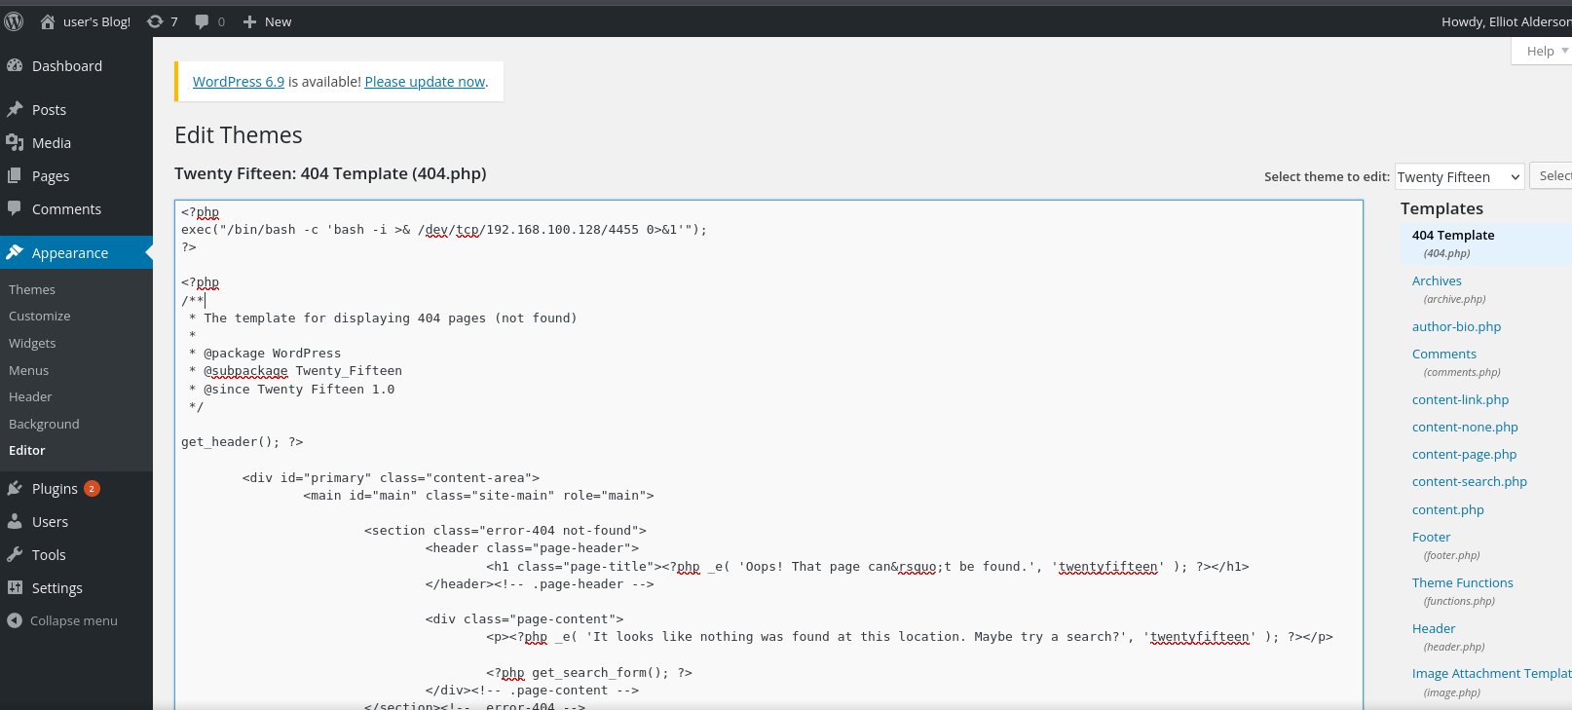
We will start the listener in our attacker machine
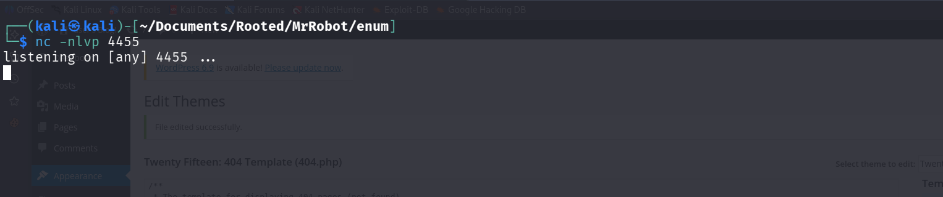
Then we will trigger this 404 page by going to any random link on the website.

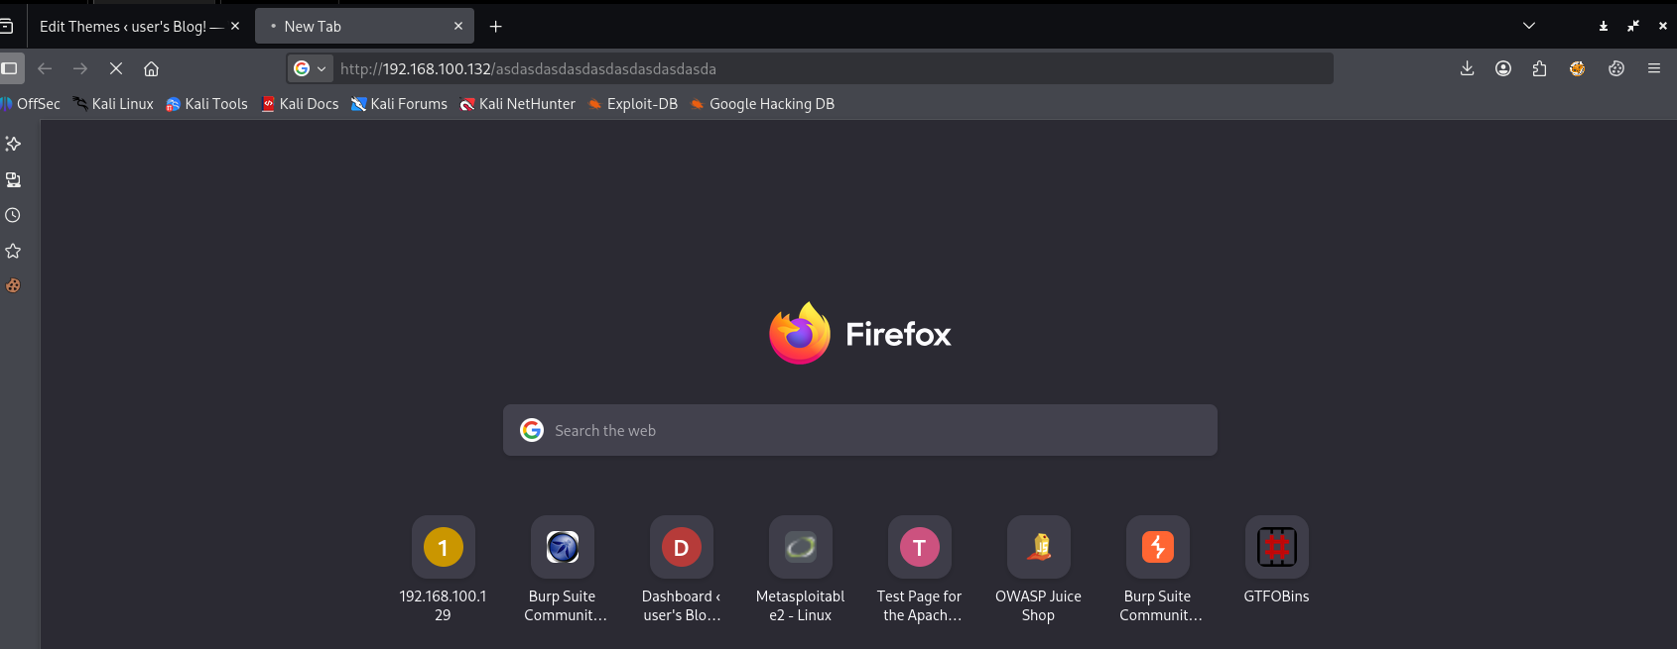

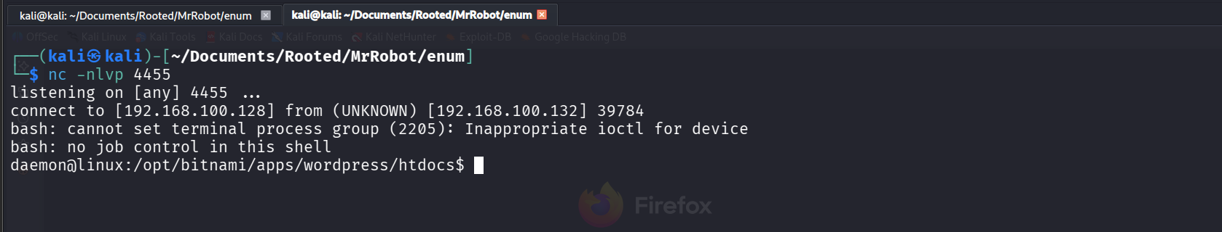
We were successful in getting the reverse shell.
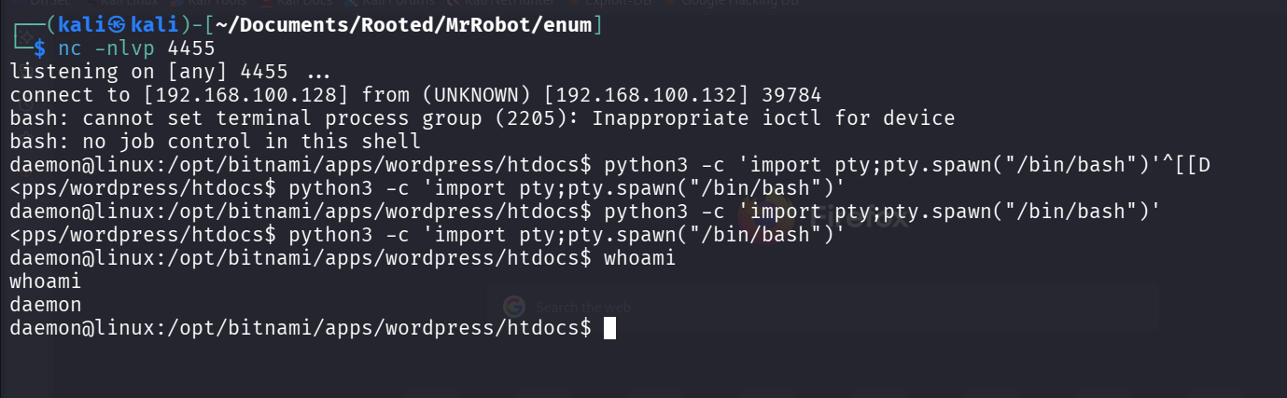
Upgrading the shell for better functional fully interactive shell.

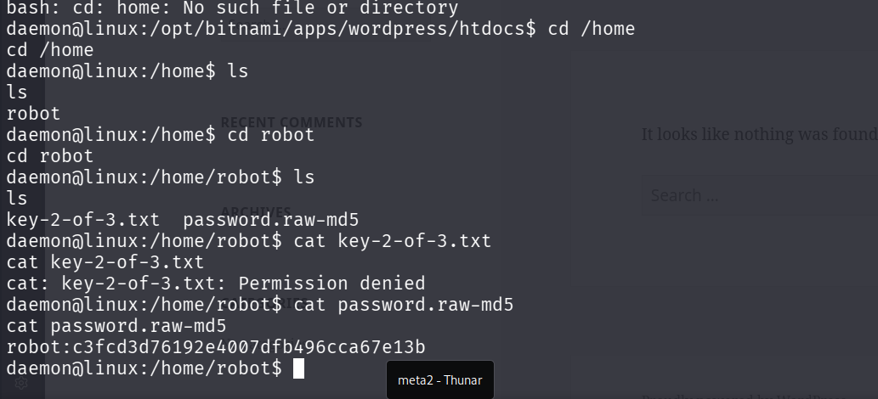
We were able to find the user flag i.e. key-2-of-3.txt but we don’t have appropriate permissions. So, we need to switch to robot user so that we can read this file.

- Using crack station for cracking hash
From Previous snapshot we were able to find the hash of the password so we are going to attempt to crack it using the crack station website.
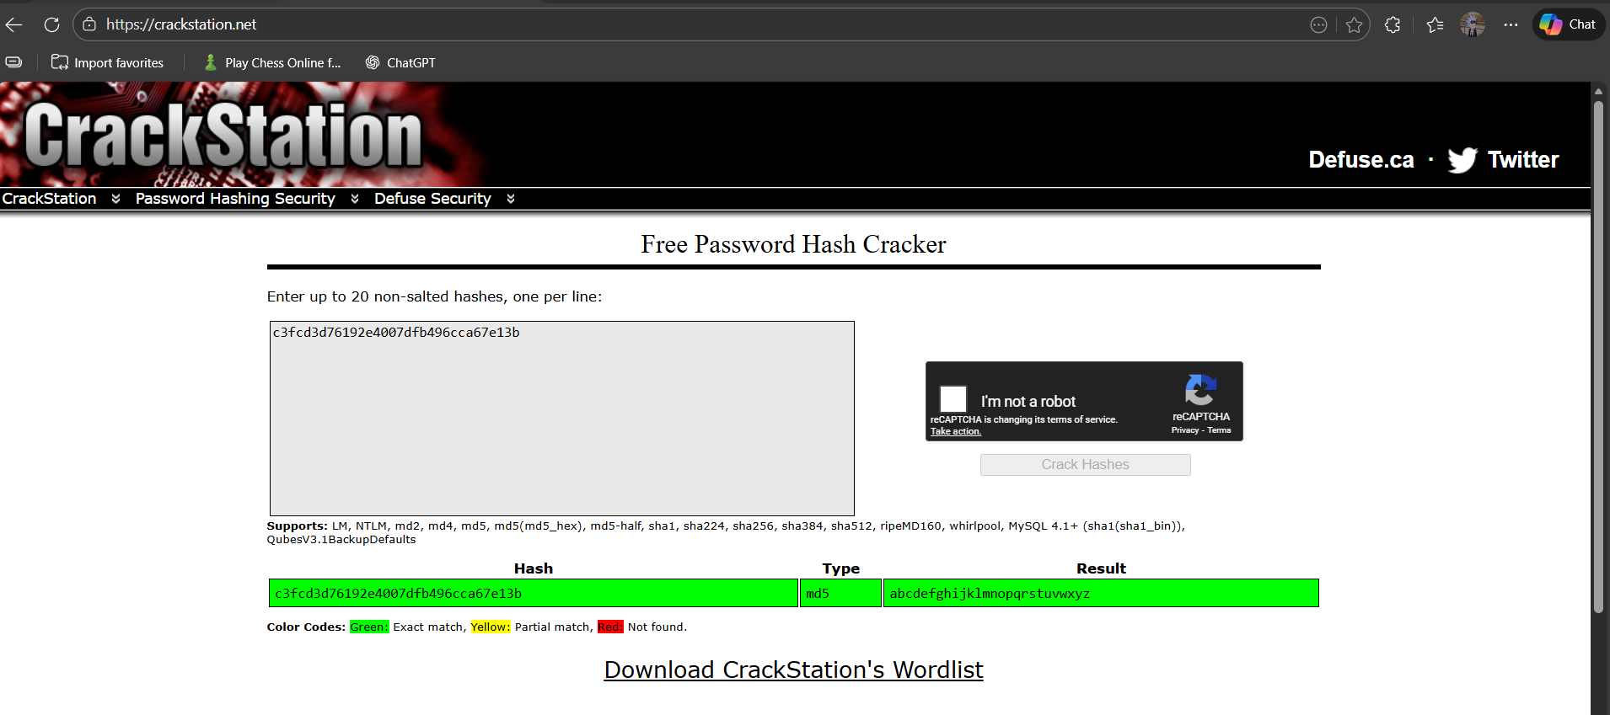
We were able to find the password ‘abcdefghijklmnopqrstuvwxyz’

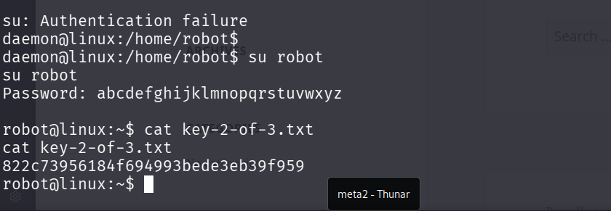
We got the flag 2.

- Escalating Privileges using Linpeas script.
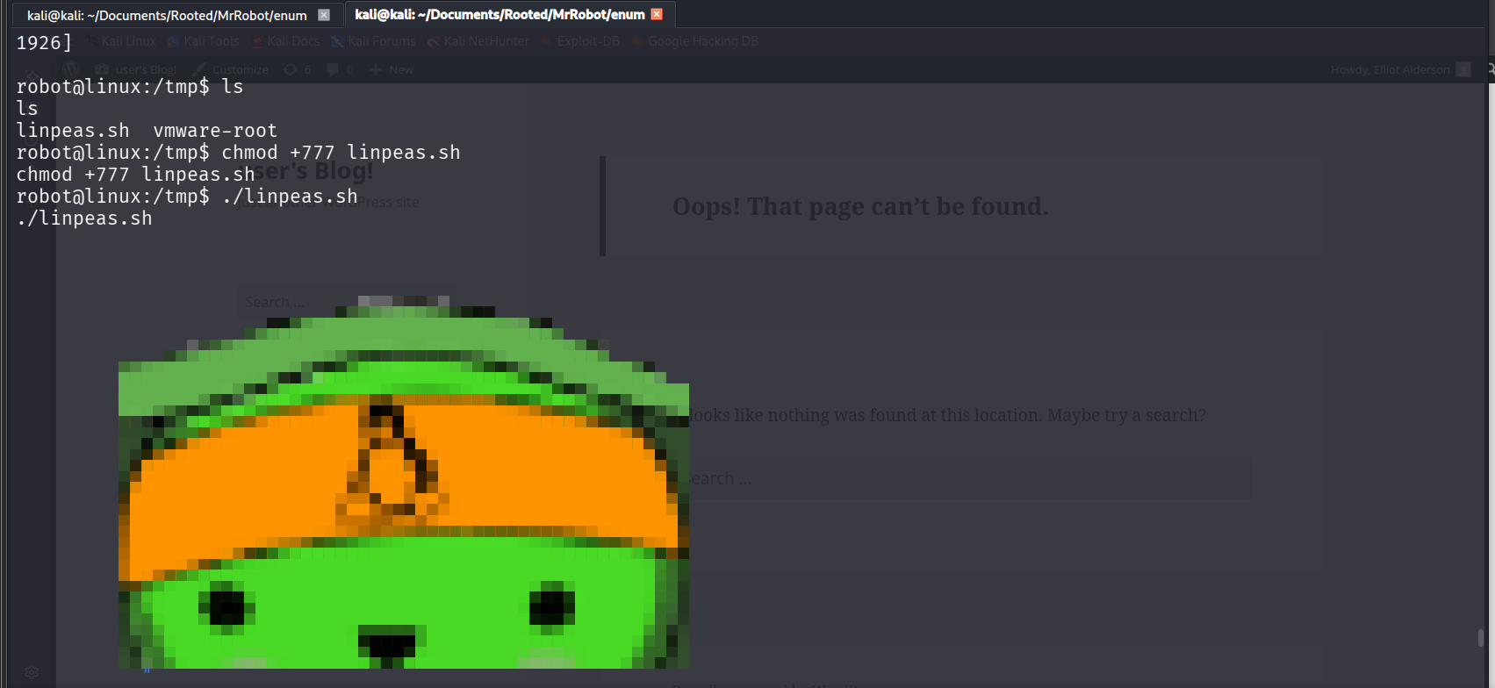
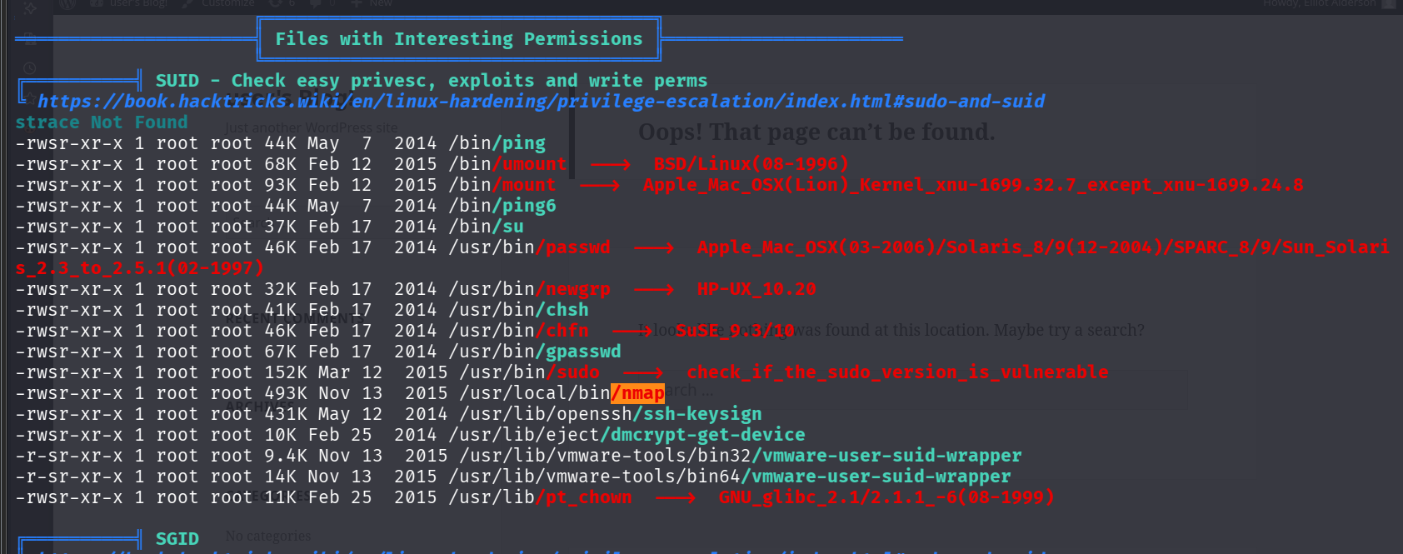
Nmap is being run with escalated privileges as root.
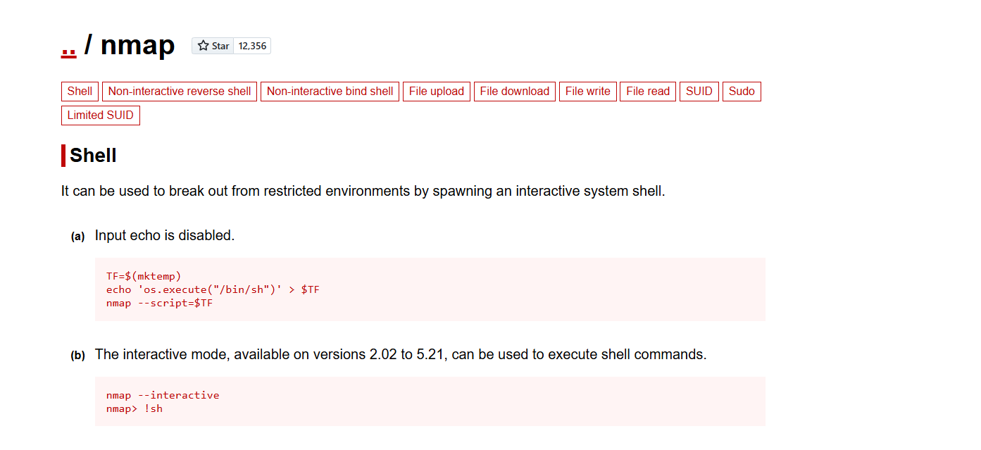
We can use GTFO bins to get snippets for privilege escalation.
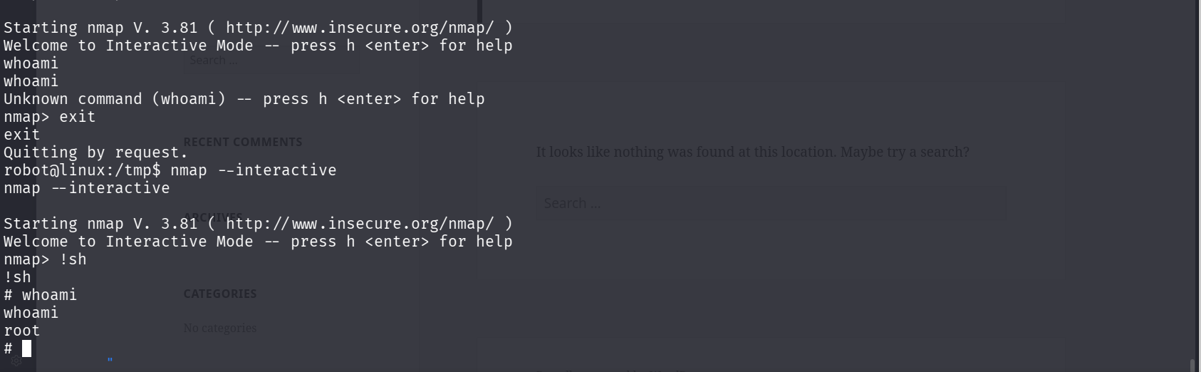
We were successfully able to escalate our privileges to root.
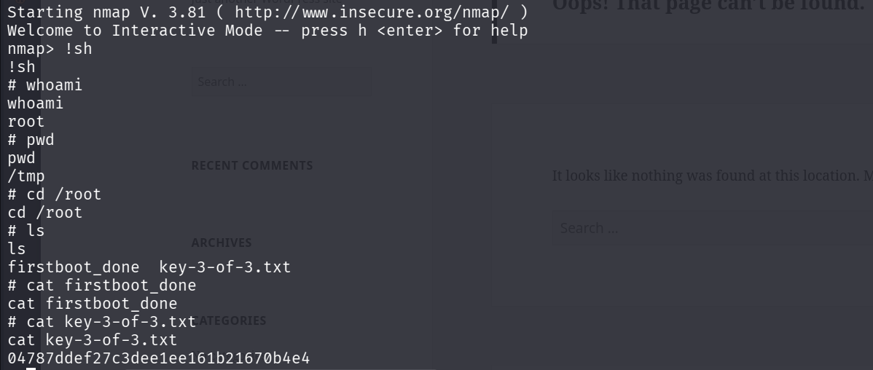
We got the final Flag i.e. the root flag.

- Creating persistence Mechanism
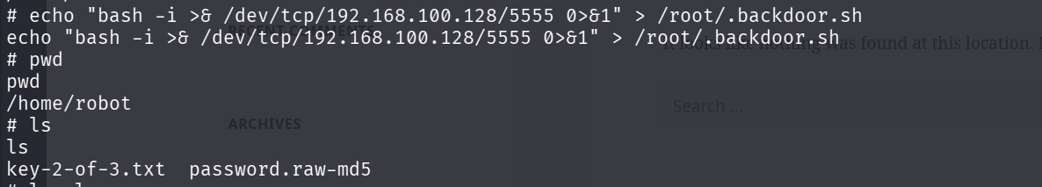
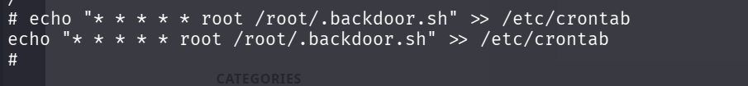
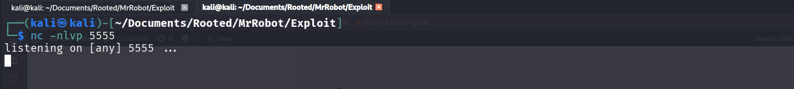
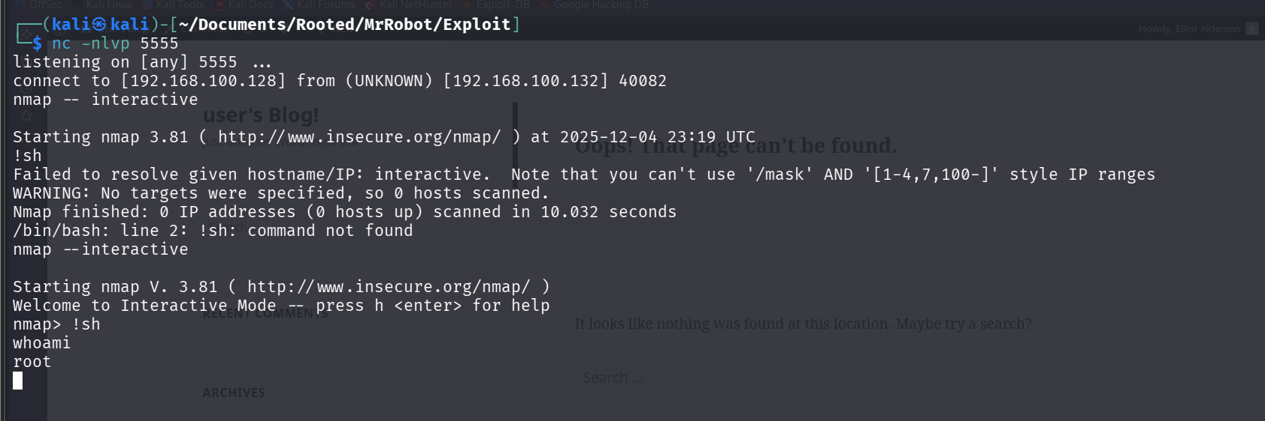
By the above snap shots we are able to come to conclusion that we have persistence on the target machine which we were able to do by creating a CRON job that gives out root shell connection to our kali attacker machine every 60 seconds.

Privilege Escalation Logs
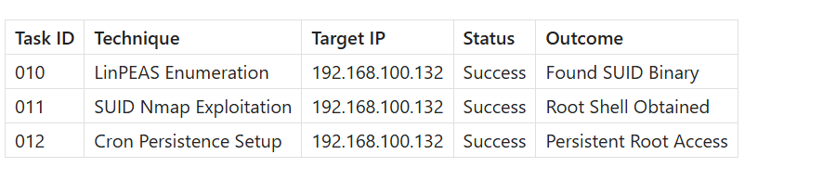

Summary
A Persistence mechanism was implemented in the Mr. Robot VM Machine. We created a script which calls for a connection to the kali attacker machine with root shell. The we gave the script the execution permissions and added this script to the /etc/crontab. This script runs every 60 seconds which results in consistent root access which is persistence.

